Problem 1:
Create an 8086 assembly program to define an array of five elements using the DUP operator. Use register indirect addressing (specifically the SI register) to iterate through the array, calculate the total sum of the elements, and store the final value in the AX register.

Codes:
.MODEL SMALL
.STACK 100H
.DATA
ARR DB 5 DUP(10, 20, 30, 40, 50)
SUM DW 0
.CODE
MAIN PROC
MOV AX, @DATA
MOV DS, AX
MOV SI, OFFSET ARR
MOV CX, 5
XOR AX, AX
XOR BX, BX
L1:
MOV BL, [SI]
ADD AX, BX
INC SI
LOOP L1
MOV SUM, AX
MOV AH, 4CH
INT 21H
MAIN ENDP
END MAIN

Output:
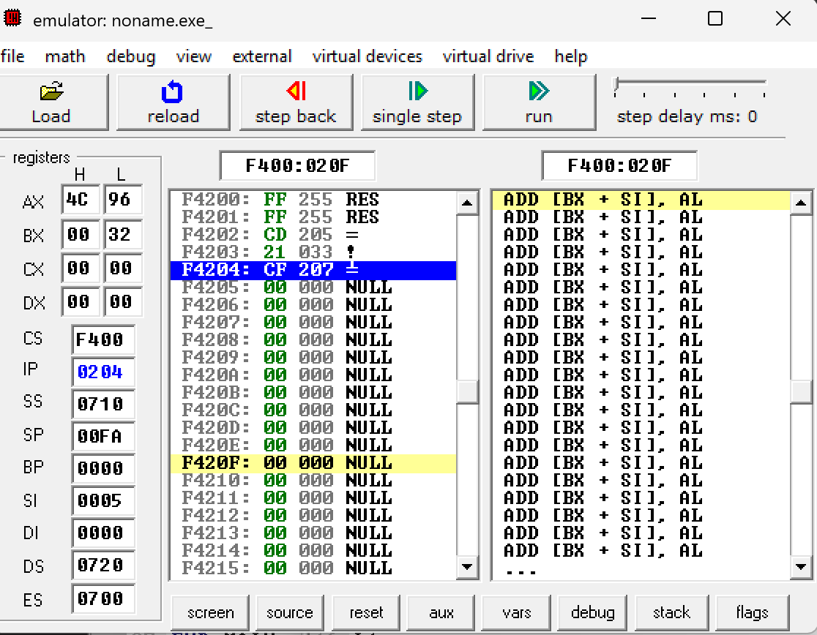

Problem 2:
Implement a program to demonstrate 8086 string instructions. The program must copy a string from one memory location to another, load a byte into a register, scan for a specific character, and compare two different strings for equality.

Codes:
.MODEL SMALL
.STACK 100H
.DATA
STR1 DB 'HELLO'
STR2 DB 5 DUP(?)
STR3 DB 'HELLO'
CHAR DB 'E'
.CODE
MAIN PROC
MOV AX, @DATA
MOV DS, AX
MOV ES, AX
LEA SI, STR1
LEA DI, STR2
MOV CX, 5
CLD
REP MOVSB
LEA SI, STR1
LODSB
LEA DI, STR1
MOV AL, CHAR
MOV CX, 5
REPE SCASB
LEA SI, STR1
LEA DI, STR3
MOV CX, 5
REPE CMPSB
MOV AH, 4CH
INT 21H
MAIN ENDP
END MAIN

Output:
